Computer Science

PROJECT

Session : 2023-24

**Name**- ARPIT GUPTA

**Class**-XII

**Section**-A

**Roll no**- 12131

**Student ID**- 20200127622

**Subject**- Computer Science

**Teacher’s name**- Mr. Adnan Siddiqi



**CERTIFICATE**

This is to certify that **ARPIT GUPTA**  of class **12th** section **“A”** of  **“Sarvodaya Bal Vidyalaya, Krishna Nagar”** has successfully completed his project work for the subject ‘Computer Science’ for class XII practical examination of the Central Board of Secondary Education in the session 2023-24

I further certify that this project is the individual work of the student.

Signature:

Date:



**ACKNOWLEDGEMENT**

I am very deeply thankful and indebted to our computer science teacher,  **MR.ADNAN SIDDIQI, PGT Computer Science**, [GSBV Krishna Nagar] for his invaluable help, advice and guidance in the preparation of this project.

I am also deeply thankful and want to express my gratitude to our

Principal, school authorities, teachers and my friends for providing me with the facilities and requisite laboratory conditions and guidance required for making this project work possible

I am deeply grateful and want to express my gratitude to Mr. Adnan Siddiqi for providing me with the conditions and every necessary help due to which this project work was possible and also for helping me learn and understand all the concepts in depth which not only came in handy while working on this project but also will help me throughout my life.

I learned a lot from this project and it helped me clear out all my doubts related to any of the concepts which came in use while preparation

[ARPIT GUPTA]

**INDEX**

**INTRODUCTION**

**Synopsis:**

In this project, we have created a program which stores the user’s input in a text file in a particular order. During the process of giving input, the program also asks for a password(use will be explained further)

Users can further fetch all the data from the text file to read and update. If the user wants to update the data then to avoid any problem(like manipulating the data by some stranger), the user, who wants to update will need a password which was given to the program when data was initially given by the input

**Project’s goal and brief introduction:**

this program was initially made on the topic of management of the patent office and research papers in the patent office.

The program made by us works on the application of very simple principles but yet takes a competitive approach and brainstorming to put every piece of the puzzle in the right place.

It aims to store the data of all research papers in a patent office to a server or a directory in the form of text file.

When compared to storing the data in SQL and Storing the data in a text file, text file came out as a big help. It is because we can store data in text files in a very formatted and disciplined order and can easily update it; it was also easier from the perspective of programming as I didn’t need to join SQL and Python.

It also helps to keep the copyright protected and to avoid altering the data by any stranger with the help of a password which is given by the user while creating the file

**SYSTEM REQUIREMENT**

Honestly there are not many requirements for running this program. Still assuming that someone might be using it in a very old device, I will mention the very minimum requirements for them as per the device I build it in :

* **OPERATING SYSTEM** : WINDOWS 7 AND ABOVE
* **PROCESSOR** : Intel(R) Core(TM) i3,i5 or i7-8700
* **CPU**  : 3.20GHz 3.19 GHz
* **RAM** : 2 GB+
* **Hard disk** : SATA 512 GB OR ABOVE
* **CD/DVD r/w multi drive combo** : (if back up required)

FLOWCHART

**physics**

**Final mathematical relation**

**Mathematical relation(if needed)**

**What do you want to do?**

**update**

**Create new file**

**author**

**Name of file**

**password**

**Subject:**

**chemistry**

**maths**

**biology**

**CS**

**accomplishment**

**image**

**introduction**

**Theory part 1**

**nxt()**

**Theory box**

**Math box**

**Image box**

**End the report**

*All the data which gets inputted gets appended in EMPLIST*

**File**

EMPLIST gets created. EMPLIST = []

*EMPLIST gets converted to string*

*All data gets written*

*File gets created by the name*

**STRING**

*Each line converted to a string*

*File.Readlines() = lines*

**Any general line is a element of the list**

**Line = x**

New text which we want to be at line ‘x’ = txt

*Lines[x-1]*

*txt*

*For line with serial no. x*

*The original text gets replaced by txt*

*Saved to*

Directory or server

Name of the file = File

*searches*

*If exists*

*If not exists*

**File does not exist**

Enter password

*If wrong*

**Wrong password**

*If correct*

*If x is in range*

*If x is not in range*

New text which we want to be at line ‘x’ = txt

**File**

*X gets appended*

*Saved to*

Directory or server

SOURCE CODE

# DATA and patent MANAGEMENT

print ("R or r for new work , U or u for insertion of data in previous titles")

a= input("what do you want to do :")

EMPLIST = []

def re():

desname= input("give a name to the file : ")

global f

f= open (desname,'w')

return (f)

def th():

theorybox = input("write your theory further here:")

EMPLIST.append(theorybox)

def num():

mathbox = "mathematical relation used or talked about in the above part : " + input("input your mathematical expression")

EMPLIST.append(mathbox)

def nxt():

nt = input(" 1 for providing text box for theory , 2 for providing numerical box , 3 for image box ,4 for ending the report:")

while nt< '4':

if nt == "1":

th()

elif nt == "2":

num()

elif nt == '3':

imagebox = input("you can give the address to any image or video you want to shaow in your work here : ")

nt = input(" 1 for providing text box for theory , 2 for providing numerical box , 3 for image box ,4 for ending the report:")

if nt == "4":

biblio=input("bibliography :")

print('report has ended, thanks for working with us')

EMPLIST.append('report ended')

EMPLIST.append(biblio)

def start():

t = input("Title/name of your project:")

T = 'TITLE : ' + t

EMPLIST.append(T)

print("p for physics, c for chemistry, b for biology, m for mathematics, cs for computer science")

global s

s = input("Subject under which it does come:")

S = 'CODE OF CONCERNED SUBJECT : ' + s

EMPLIST.append(S)

return (S)

def password():

inp2= int(input("input a password for your work, it will come in handy in future if you would like to edit any thing in your work : "))

istring = str(inp2)

global rpassword

rpassword = 'PASSWORD : ' + istring

return rpassword

if a == 'R' or a == 'r':

start()

yourname = 'author(s)' + input('name of people who worked in this project : ') + ':'

EMPLIST.append(yourname)

re()

password()

EMPLIST.append(rpassword)

if s == 'p' or s == 'P' or s == 'c' or s == 'C' or s == 'm' or s == 'M':

q = "ACCOMPLISHMENT MADE BY THE WORK: " + input("question/problem solved by your study or accomplishment made : ")

imagebox = input("you can give the address to any image or video you want to shaow in your work here : ")

ideabox = "INTRODUCTION: " + input("your theory's introduction: ")

m0box = "FINAL MATHEMATICAL RELATION FOUND (if any) : " + input("you can write here if there is any final matematical relation or derivation which your study suggests ,here :")

theorybox = input("write part 1 of details of your theory, you will get a mathbox below for writing any mathematical relation related to this part of thepory :")

mathbox = "MATHEMATIAL RELATION USED OR TALKED ABOUT IN ABOVE PART : " +input("write any mathematical expression for part 1 of your theory:")

EMPLIST.append(q)

EMPLIST.append(imagebox)

EMPLIST.append(ideabox)

EMPLIST.append(m0box)

EMPLIST.append(theorybox)

EMPLIST.append(mathbox)

nxt()

elif s == 'b' or s == 'B':

q = "ACCOMPLISHMENT MADE BY THE WORK: " + input("accomplishment made by the work : ")

ideabox = "INTRODUCTION: " + input("your theory's introduction:")

imagebox = input("you can give the address to any image you want to shaow in your work here : ")

m0box = "mathematical relation which can be concluded from this study : " + input("you can write here the any mathematical relation which your work suggests, if any :")

theorybox = input("write part 1 of details of your theory:")

mathbox = "mathematical relation used or talked about in the above part : " + input("write any mathematical expression for part 1 of your theory:")

EMPLIST.append(q)

EMPLIST.append(ideabox)

EMPLIST.append(imagebox)

EMPLIST.append(m0box)

EMPLIST.append(theorybox)

EMPLIST.append(mathbox)

nxt()

elif s == 'cs' or s == 'CS' or s == 'Cs' or s == 'cS':

q = "ACCOMPLISHMENT MADE BY THE WORK: " + input("accomplishment made by your study : ")

imagebox = input("you can give the address to any image you want to shaow in your work here : ")

ideabox = "INTRODUCTION: " + input("your work's introduction:")

m0box = "MATHEMATICAL RELATION(s) USED HERE ARE: " + input("you can write here the any mathematical relation which you have used in your work, if any :")

theorybox = input("you will further get a mathbox for providing mathematical relation used in this part of theory . write part 1 of details of your theory:")

mathbox = input("write any mathematical expression for part 1 of your theory:")

EMPLIST.append(q)

EMPLIST.append(imagebox)

EMPLIST.append(ideabox)

EMPLIST.append(m0box)

EMPLIST.append(theorybox)

EMPLIST.append(mathbox)

nxt()

string1= '\n'.join(EMPLIST)

f.writelines(string1)

f.close()

if a == 'u' or a == 'U':

EMPLIST.append("Updated File :")

e = input("Name of the file you want to edit: ")

passcode = int(input("password : "))

passcode1= str(passcode)

filere = open(e, 'r')

lines = filere.readlines()

p = "PASSWORD : " + passcode1

string2= '\n'.join(lines)

if p in string2:

print(''.join(lines))

linenum = int(input('The Serial no. of line you want to update: '))

k = linenum - 1

if k >= len(lines):

ufile = open(e, 'a')

t1 = int(input("How many lines you want to add: "))

i = 0

if i < t1 :

txt = input("the desired text you want to append : ") + '\n'

ufile.write(txt)

ufile.close()

file = open(e, 'r')

print(file.read())

elif k < len(lines):

txt = input('The new text you want at desired line: ')

lines[k] = txt + '\n'

ufile = open(e, 'w')

ufile.writelines(lines)

ufile.close()

file = open(e, 'r')

print(file.read())

else:

print("wrong password")

OUTPUT

1. When a = r or R :

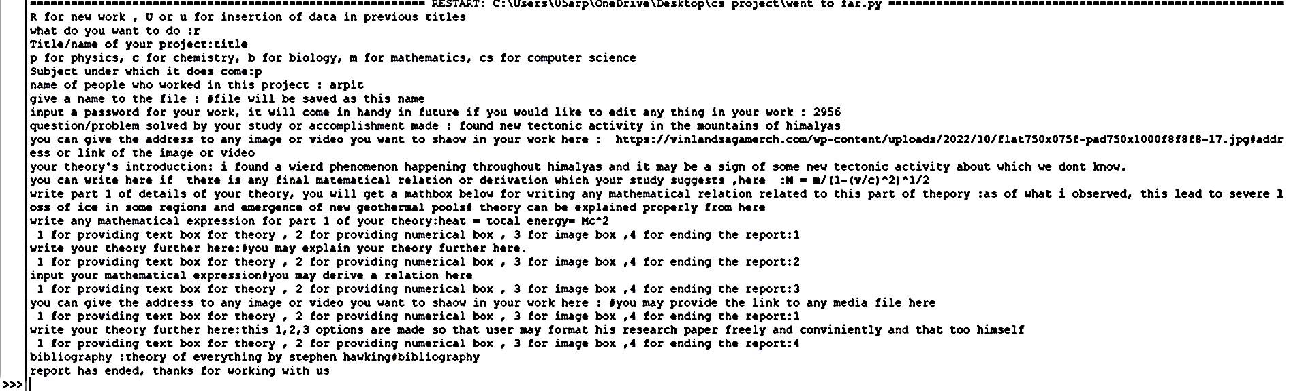 Input :

File :

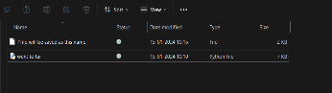

File saved in the directory or server

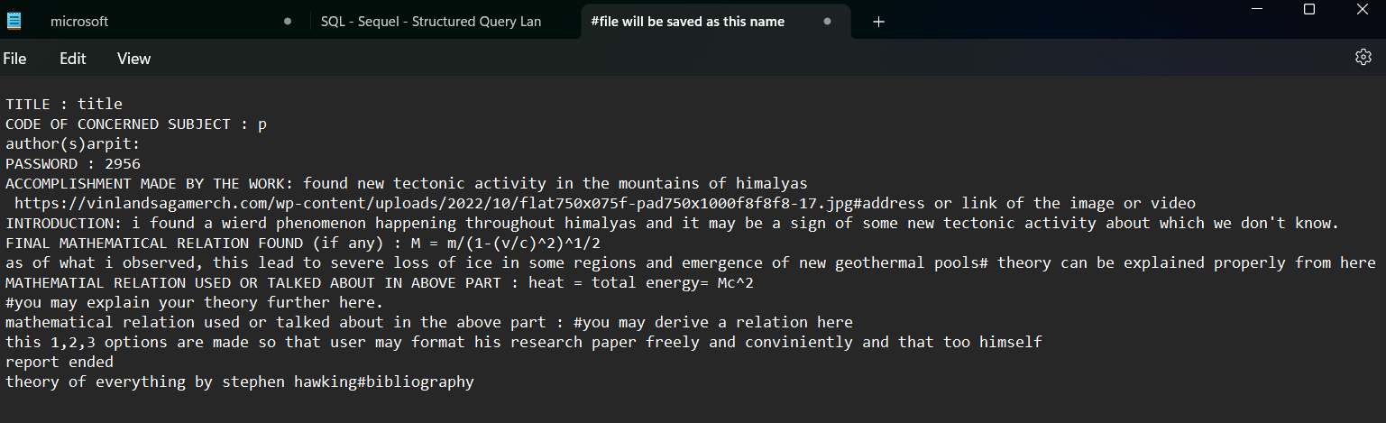outout :

All the data given as input is saved in the order

1. When a = u or U :

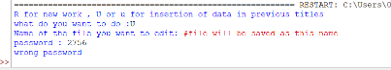

You can not edit the file

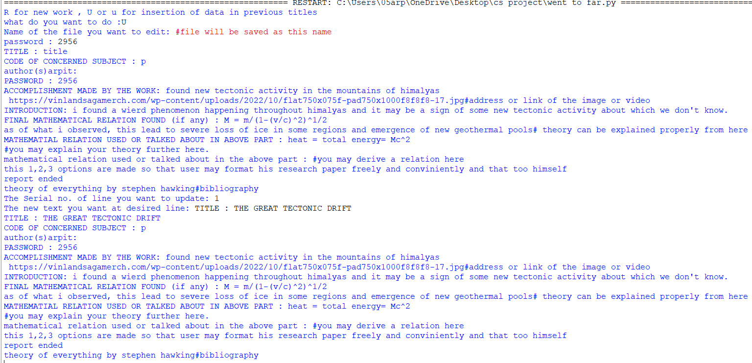

1)First, it prints all the lines starting from title. You have to input the serial no. of the line you want to edit  
2)now enter the new text you want there  
3)old text is replaced by new one and the file with your new text is printed

When the password is incorrect :

When the password is correct :

When the password is correct :

Above we gave the command to change the title and it is changed and saved

Output

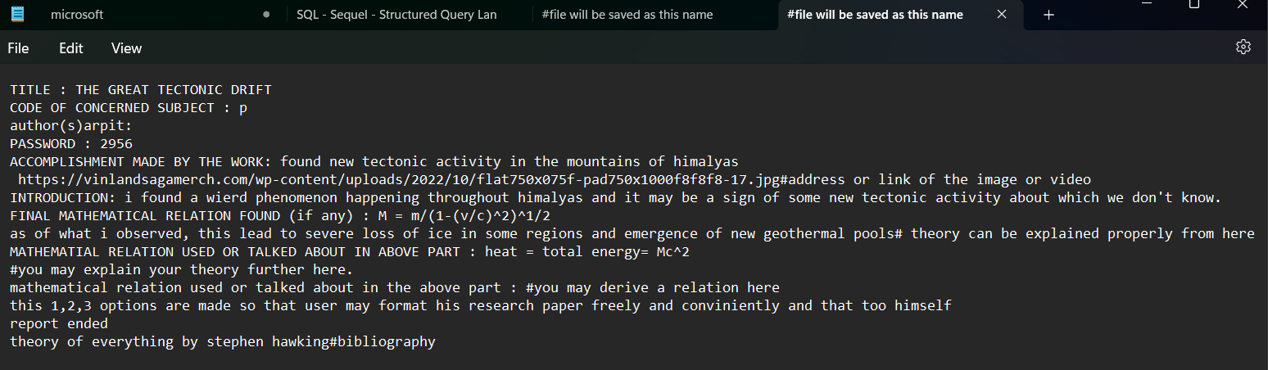Change in text file :

BIBLIOGRAPHY :

1. COPILOT : for eliminating a error in input and formatting
2. My friend : can’t mention their name
3. NCERT cs textbook : for eliminating syntax related errors and theory
4. Wikipedia & bing : for theory related issues